INSECTICIDES INDIA LTD.
PLOT NO. Z/50,
PART - I, DAHEJ-SEZ
TALUKA- VAGRA -392130
DISTRICT- BHARUCH. GUJARAT (INDIA)
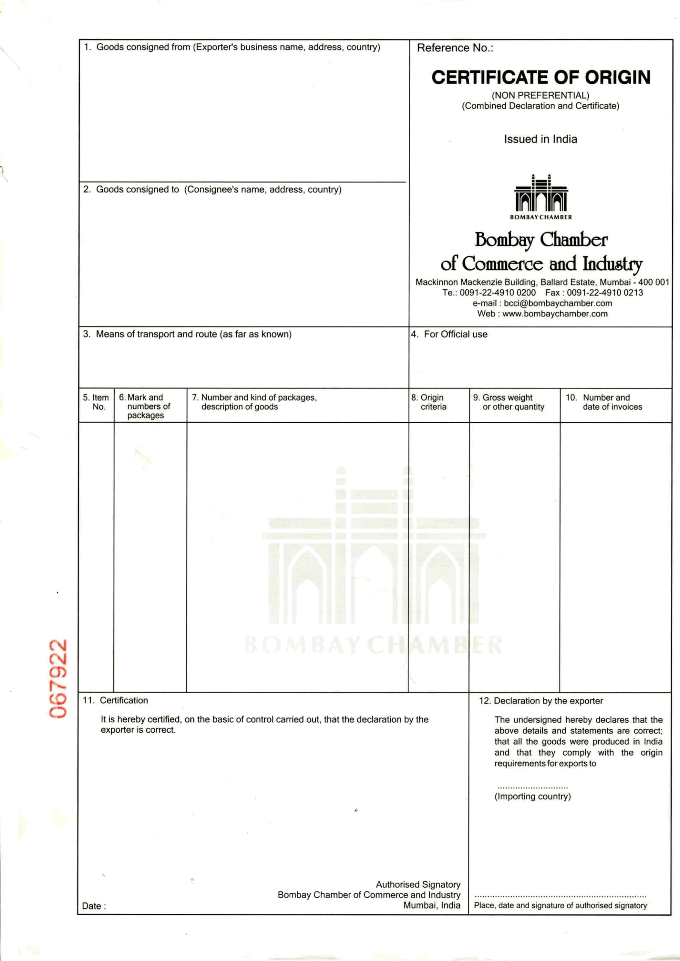
GSTIN - 24AAACI3076P2ZA

AFRIQUE PHYTO PLUS
47, RUE ALEX FLEMING, ZONE 4 MARCORY
15 BP 771 ABIDJAN
15/REP, DE COTE D'IVOIRE
TEL:+225 21 355614 / FAX :+225 21355615
CONTACT PERSON ; MR. MOHAMED HAMZA
Email ID : m.hamza@afriquephytoplus.com
MOB : +225 08088494

HAZIRA , INDIA TO PORT ABIDJAN, IVORY COAST
VESSEL & VOY : APL NEW YORK Voyage No - 0EG89W1MA

COUNTRY 3x40 ft HQ FCL CONTS INDIA GROSS WEIGHT INV.NO. 19 IVORY COAST 5900 CORRUGATED BOXES ONLY : 71258.00 KG
2800 Corrugated Boxes
ORIGIN INSECTICIDES FOR AGRICULTURE PURPOSE NET WEIGHT : Invoice Dtd: INDIA LAMBDA CYHALOTHRIN 2.5% EC : 52525.00 KG 29.07.2020
C-BOX. 01-2800 (H.S. CODE NO . 3808.91.99)
BATCH NO. D0049 PACKING: 100 ML X 100 PET BOTTLE = 10 Ltr
Qty : 28000 LTR “WE CERTIFY THAT
C-BOX. 01-3100 UN no. : 3351, Class :6.1 Packing Group :III THE GOODS ARE BATCH NO.D0019 INDIAN ORIGIN.”
3100 Corrugated Boxes
C-BOX. 01-1050 INSECTICIDES FOR AGRICULTURE PURPOSE
BATCH NO E0013 CYPERMETHRIN 5% EC (W/V)
CONTAINER NO. (H.S. CODE NO : 3808.91.35)
TCLU6544550/40’HQ PACKING: 1 LTR X 10 PET BOTTLE = 10 Ltr
APHU7308732/40’HQ QTY : 31000 LTR
CMAU4223286/40’HQ UN no. : 3351, Class :6.1 Packing Group :III
SHIPPING LINE SEAL NO
INV NO.: 19 / 29.07.2020
G6633976 SB NO: 4156307 DATED..29.07.2020
G6633886 BL NO.EDP0121425 DATED.03.08.2020
G6633885 BSC NO: 871597
IEC NO: 0501068023 BRANCH NO. 11
.

IVORY COAST
DATE: 05.08.2020

